BJ Global Risk & Business Consulting, Ltd

**Company Profile 2020**

**Banze JJ**

**J.Banze@Outlook.com**

**Company Profile 2020**



**Contact Us:**

[**BJ.BusinessRiskConsulting@Outlook.Com**](mailto:BJ.BusinessRiskConsulting@Outlook.Com)

[**BJ.RiskMozambique@Outlook.Com**](mailto:BJ.RiskMozambique@Outlook.Com)

**Cell: +258 84 or 86 3253 621**

TABLE OF CONTENTS:

**1.** **Our Strategy** 1

**2.** **Who We Are** 3

**3.** **Vision & Mission** 4

**4.** **Our Values and Commitment** 5

**5.** **Our Services** 6

**6.** **Business Risk, Security and Safety** 7

**7.** **Leadership & Business Process** 8

**8.** **Procurement & Logistics Services** 9

**9.** **Our Local and Global Support** 10

**10.** **Target Market | Segments | Industries** 11

**11.** **Intended Company Organogram “BJ Global Risk & Business Consulting”** 12

# **Our Strategy**

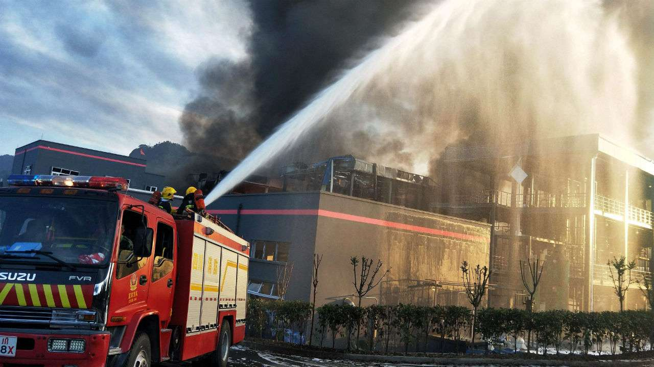

**Ensuring Your Business Continuity by providing:**

* Expertise to help you identify, assess, list and plan risk reponse to ensure your business integrity, asset protection and loss prevention;
* Expertise to help you assess your admin and operational processes, business and staff performance, and time management issues;
* Local and international procurement of specialized equipment and materials;
* Resourceful gap analysis and training in leadership, safety, physical security, crisis management, territory defense, anti-terrorism, etc.

# **Who We Are**

**BJ Global Risk & Business Consulting** is a Mozambican company specializing in Enterprise Risk Management consultancy, Business Management consultancy, and provision of Procurement and Logistics services.

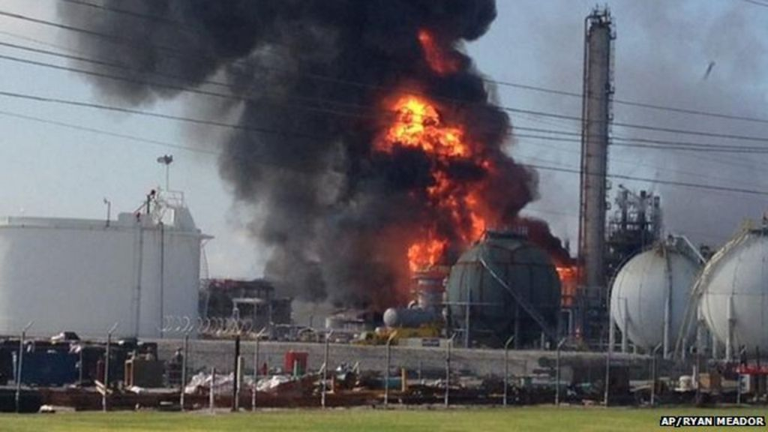

# **Vision & Mission**

**Mission:** Be part of successful the implementation of corporate governance and risk compliance and business continuity policies carried out by both government institutions, private sector, diplomatic and NGOs.

**Vision:** During the next two years we want to become preferred supplier of reliable risk and business consulting services to major corporations in Mozambique by providing them with dependable expertise which will help achieve their business objectives as well as comply with their CRG policies and process management standards.

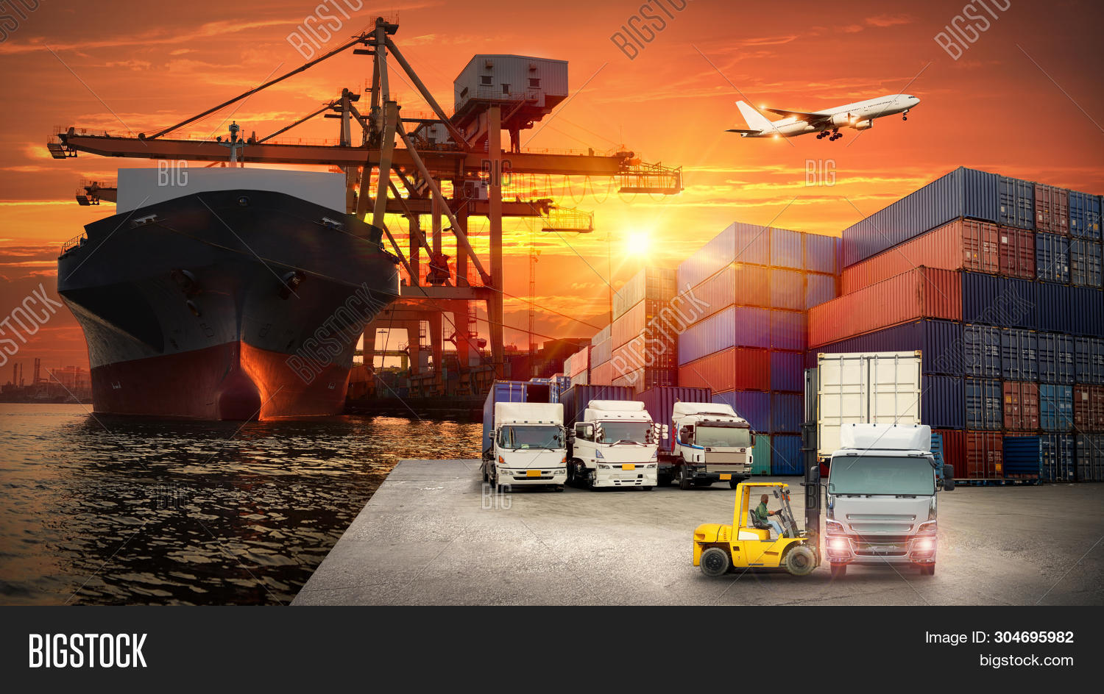

# **Our Values and Commitment**

**Our Values:**

* We bring expertise, carry confidence and ensure delivery!
* We are accountable for everything we do, always acting with integrity and transparency!
* We are always keen to share knowledge, listen to and learn from our mistakes!

**Our Commitment:**

* We will only accept and commit to projects we know we can deliver!

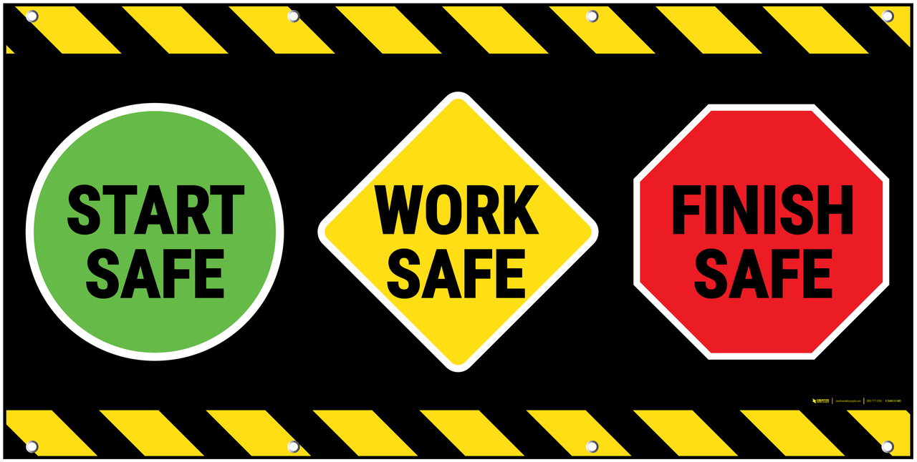

# **Our Services**

**Consultancy and advisory services in:**

1. Business risk management, health & safety;
2. Business leadership & process management;
3. Physical security and secure mobility risk;
4. Crisis management, territory defense, conflicts & anti-terrorism;
5. Provision of specialized procurement & logistics services (armored vehicles, aircrafts, surveillance boats, leisure boats, etc.).



# **Business Risk, Security and Safety**

**Objectives:**

Help organizations comply with their GRC policies and reliably achieve their financial and operational objectives, address uncertainty and act with integrity through:

* Risk identification and assessment;
* Risk analysis and listing in risk registers;
* Risk strategies, control and reporting mechanisms;
* Risk management plans.

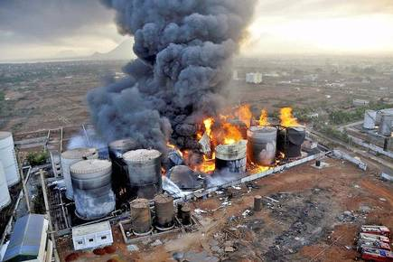

# **Leadership & Business Process**

**Objectives:**

Provide reliable services to help organizations achieve their value chain and business objectives, such as:

* Compliance with GRC policies;
* Improve planning and control processes;
* Improve performance and evaluation processes;
* Identify gaps, inefficiencies and response planning.



# **Procurement & Logistics Services**

**Objectives:**

Global sourcing of specialized equipment and materials for private use, physical security & secure mobility, health & safety, territory defense and law enforcement (Military and Police):

* Security, Health & Safety (electronic security equipment, safety equipment, armored vehicles, drones, etc.);
* Defense and Law enforcement (armored vehicles, riot tools and equipment, aircrafts, surveillance boats, etc.);
* Logistics, including customs clearance and warehousing process.

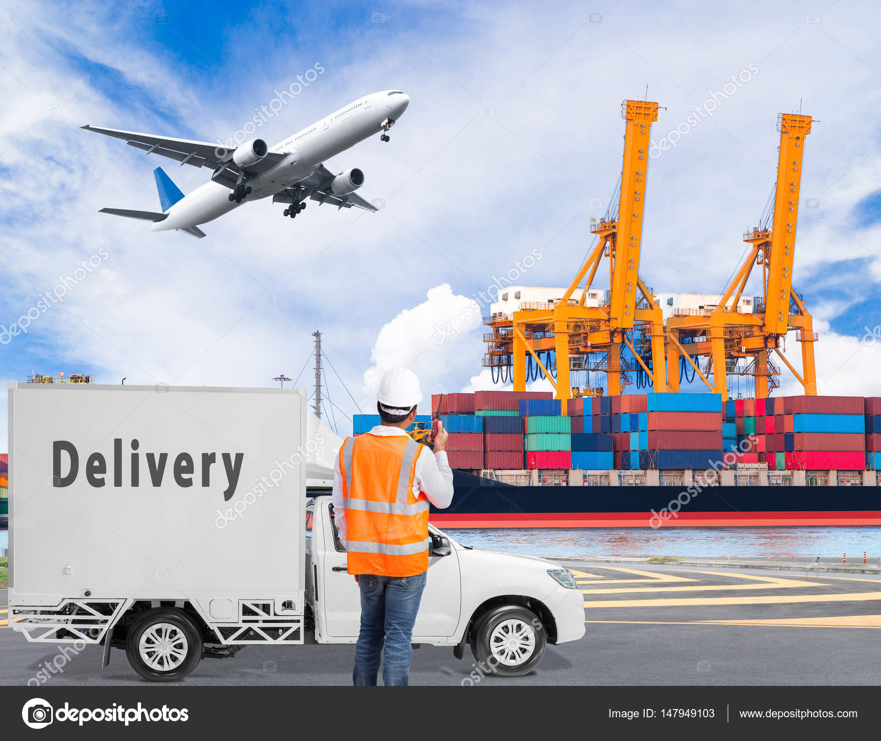

# **Our Local and Global Support**

# **Target Market | Segments | Industries**

* Government, Diplomatic Sector & NGO’s;
* Private Sector;
* Energy, Water & Infrastructure, Mining, Construction, Oil & Gas;
* Transport, Logistics & Warehousing;
* Ports and Railways;
* Manufacturing, Construction Yards and Quarries;
* Financial Sector (Banks, Exchange Houses);
* Supply Chain Value and Agro-processing;
* Other Sectors.

# **Intended Company Organogram “BJ Global Risk & Business Consulting”**